Module Name: Login Page
Test Case ID: 01
Webpage URL: https://practicetestautomation.com/practice-test-login/

Scenario ID: 1
Scenario: Sign up with valid credentials
Test Steps:
- Open Login Page
- EnterUsername
- Enter Password
- Click on Sign Up
Screenshot of open Login page : 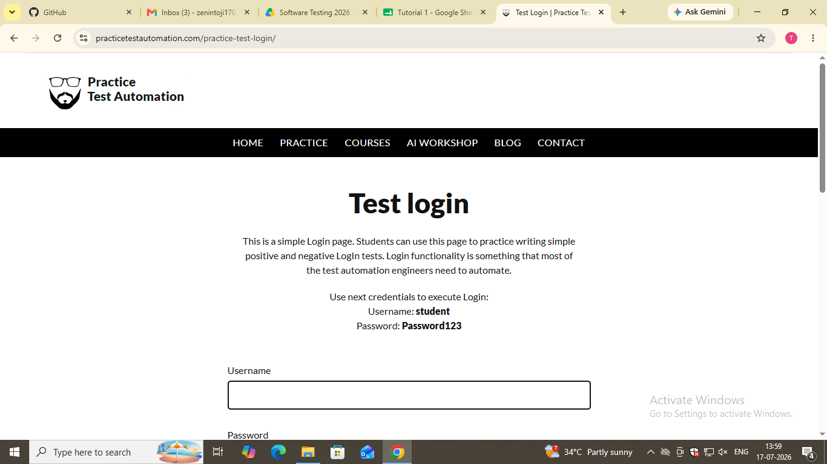
Screenshot of Enter Username : 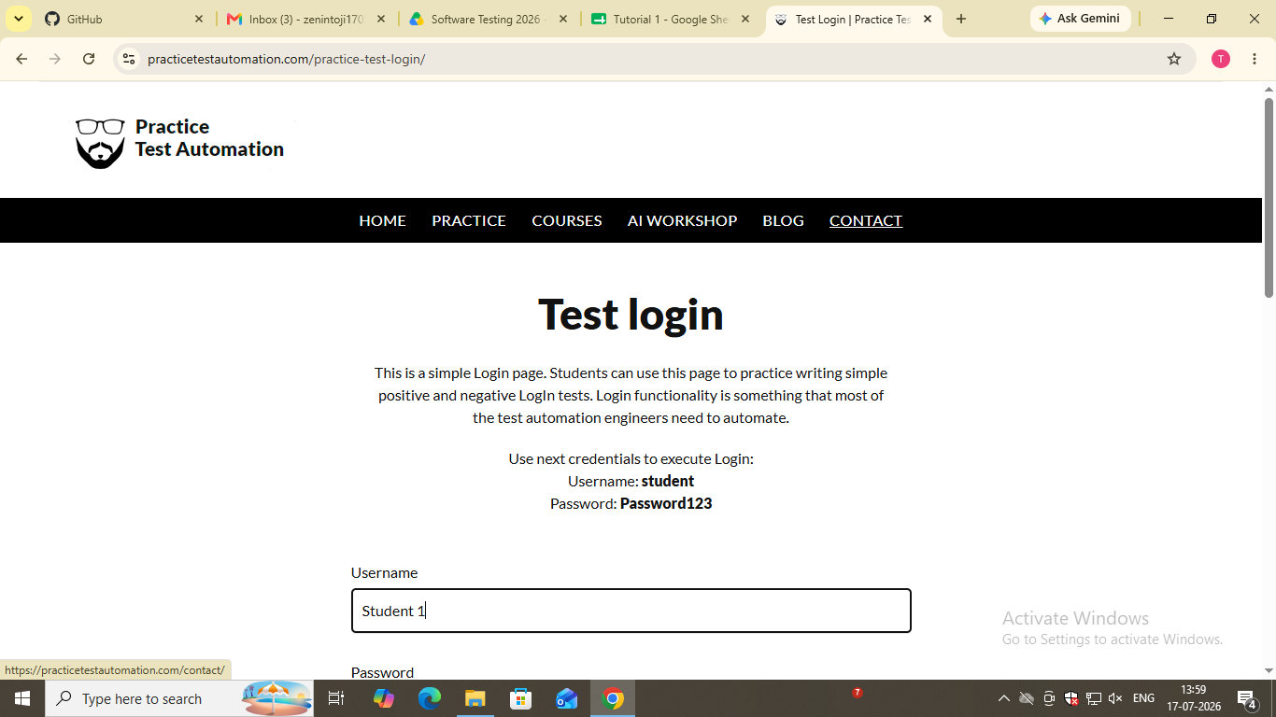
Screenshot of Enter Password : 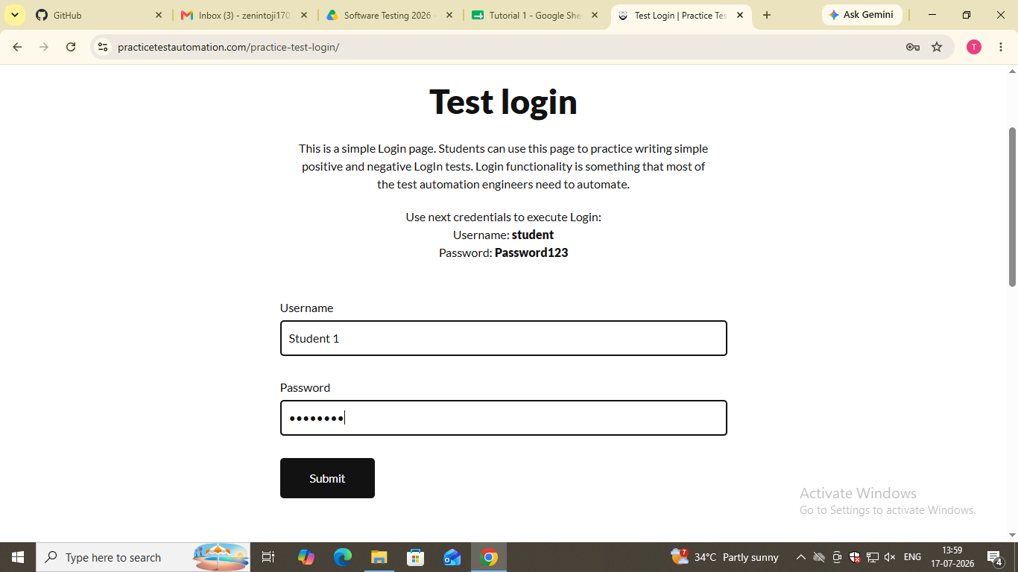
Screenshot of after Submit :
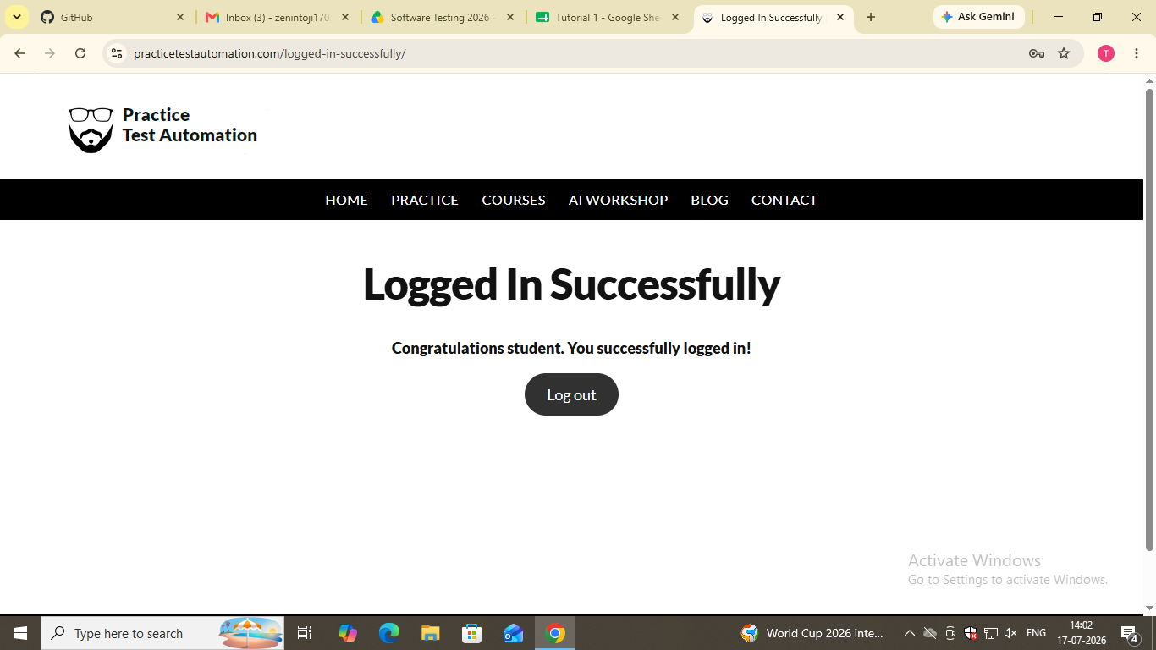

Scenario ID:2 :=
Scenario: Sign up with valid credentials
Test Steps:
- Open Login Page
- EnterUsername
- Enter Password
- Click on Sign Up
Screenshot of open Login page :
Screenshot of Enter Username : 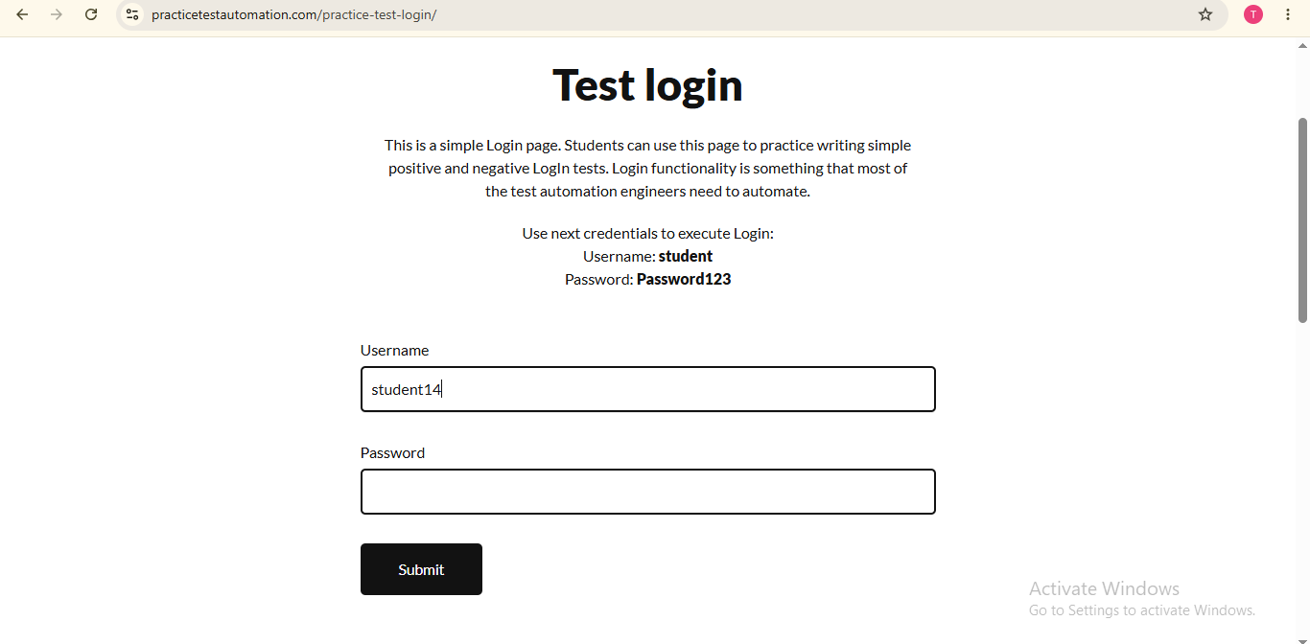
Screenshot of Enter Password :
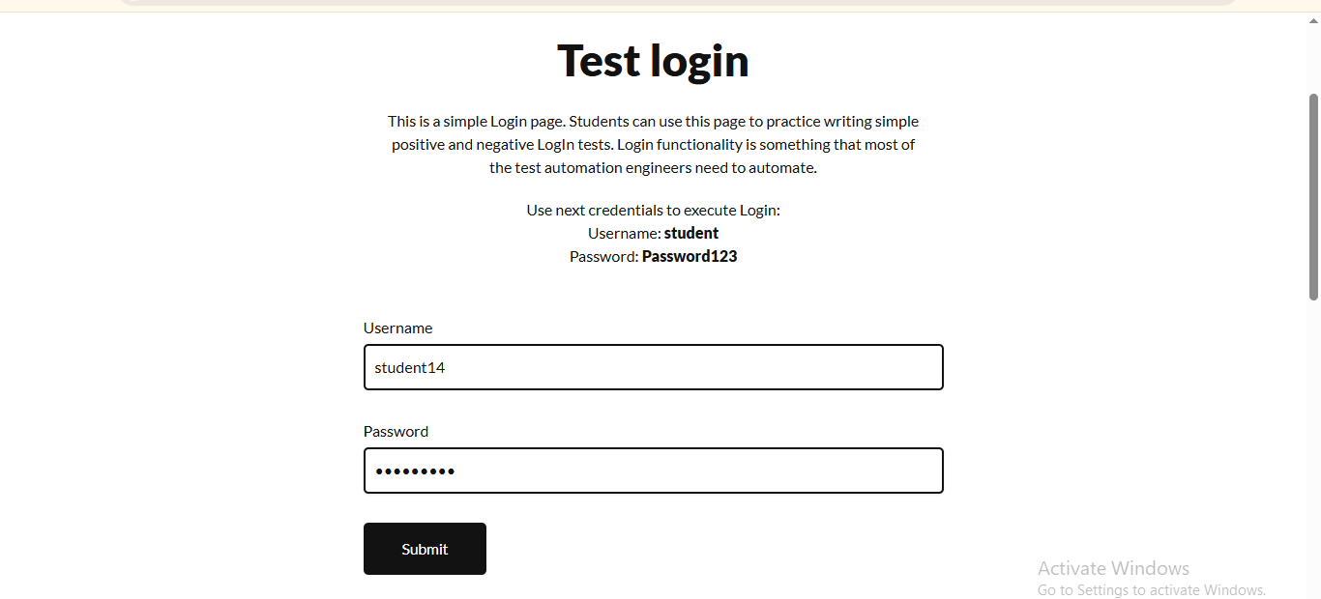
Screenshot of after Submit :
